**Project Title:** Blockchain Hash Chain Visualizer

**Name**: Ahmed Umar  
**University**: FAST NUCES Islamabad  
**Date**: 19th June 25

Contents

1. Introduction 3

2. Tools and Technologies Used 3

3. Concept Overview 3

4. Implementation Steps 3

5. Features 4

6. Screenshots 4

7. Conclusion 5

# 1. Introduction

This project demonstrates the core concept of blockchain technology using a simple visual web application. The main goal was to understand how hash functions are used to link blocks together, and how blockchain ensures immutability through hashing.

# 2. Tools and Technologies Used

* HTML: For page structure
* CSS: For styling and layout
* JavaScript: For blockchain logic and interactivity
* CryptoJS: For applying SHA-256 hashing
* GitHub Pages: For deployment

# 3. Concept Overview

A blockchain is a chain of blocks, where each block contains data, a timestamp, and a hash. Each block also stores the hash of the previous block, forming a secure chain. If even one block is modified, the hash changes and the chain breaks, showing that the data was tampered with.

# 4. Implementation Steps

* Created a Block class to represent each block.
* Implemented a Blockchain class to manage the chain.
* Created an HTML interface for users to input data.
* Used JavaScript to dynamically generate blocks and link them using previous hashes.
* Applied SHA-256 hashing via the CryptoJS library.

# 5. Features

* Genesis block created by default.
* Users can add new blocks with custom data.
* Each block shows its data, hash, and previous hash.
* All blocks are displayed visually.
* Demonstrates how immutability works in a real blockchain.

# 6. Screenshots

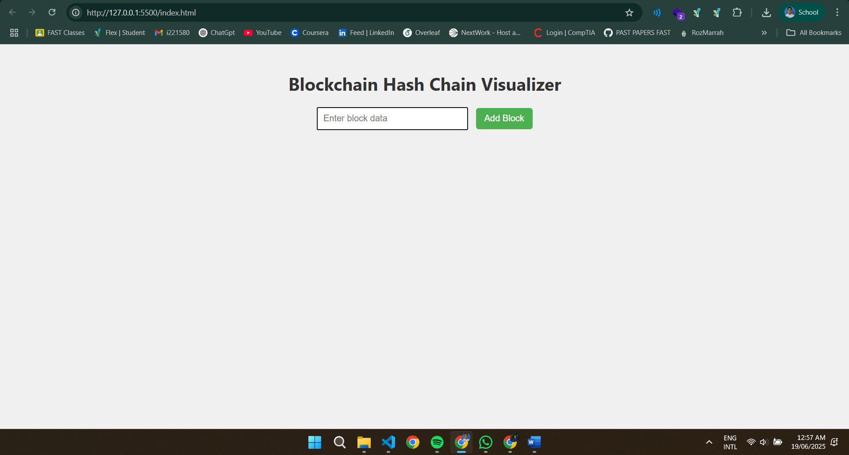

# 7. Conclusion

Through this project, I gained a practical understanding of how blockchains work and how hashing ensures data integrity. This also helped me strengthen my JavaScript and frontend development skills. In future, I plan to add tamper detection and visualization of Merkle trees.